

EXAMINING THE CURRENT COLLECTION DEVELOPMENT PRACTICES IN THE UGANDA INSTITUTE OF INFORMATION AND COMMUNICATIONS TECHNOLOGY LIBRARY

NALUNKUMA ELIZABETH
REG. NO: S19M63/015

A DISSERTATION SUBMITTED TO THE FACULTY OF EDUCATION AND LANGUAGES IN PARTIAL FULFILLMENT OF THE REQUIREMENTS FOR THE AWARD OF A MASTERS OF LIBRARY AND INFORMATION
STUDIES OF UGANDA CHRISTIAN
UNIVERSITY

SEPTEMBER, 2023

DECLARATION

I, Elizabeth Nalunkuma, declare that this dissertation entitled: Examining the Current Collection Development Practices in the Uganda Institute of Information And Communications Technology Library is original and has not been published elsewhere for any award.

Elizabeth Nalunkuma
October 14 2022

APPROVAL

I hereby declare that this dissertation entitled: Examining the current Collection Development Practices in the Uganda Institute of Information And Communications Technology Library was conducted under my supervision and is now ready for submission.

Mr. Ssekitto Francis


DEDICATION

I dedicate this dissertation to God the Almighty, my family, my husband, my children and my friends for the encouragement and support throughout my education, and not forgetting my late grandmother, Dorotia Nansubuga (R.I.P) who was always there for me.

ACKNOWLEDGEMENTS

Special thanks to the Lord for the gift of life and all the provisions. I also extend my deep appreciation and special thanks to my husband, Fredrick, and my children, Dorah, Bridget, Bryan and Benjamin, for the financial and all aspects of support they have given to me. You have surely you sacrificed a lot. May God bless you and reward you abundantly.

My profound gratitude also goes to my research supervisor, Mr. Ssekitto Francis, for his mentorship, expert advice, encouragement, patience, reserved comments and time he provided throughout this research process.

God bless you all.

TABLE OF CONTENTS

DECLARATION i
APPROVAL ii
DEDICATION iii
ACKNOWLEDGEMENTS iv
TABLE OF CONTENTS v
FIGURES ix
TABLES x
ACRONYMS xi
ABSTRACT xii
CHAPTER ONE: INTRODUCTION TO THE STUDY
1.1 Background to the study 1
1.2 Background to the UICT library 2
1.3 Statement of the problem 2
1.4 Aim of the study 3
1.5 Objectives of the study 3
1.6 Research questions 3
1.7 Significance of the study 3
1.8 Scope of the study 4
1.8.1 Content scope 4
1.8.2 Time scope 4
1.9 Conceptual framework 4
1.10 Justification of the study 5
1.11 Definition of key operational terms 6
CHAPTER TWO: LITERATURE REVIEW
2.1 Introduction 7
2.2 Collection Development Practices in Academic Libraries 7
2.3 Factors Influencing Collection Development in Academic Libraries 11
2.4 Challenges Affecting Collection Development in Academic Libraries 13
2.4.1 Budget challenges 13
2.4.2 Determining the quantity of collections required 13
2.4.3 Lack of subject specialist librarians 13
2.4.4 Traditional processes for collection development 13
2.4.5 Limited staff 14
2.4.6 Weak ties between library sections 14
2.4.7 Inadequate training of librarians 14
2.4.8 Lack of collection development policies 14
2.5 Strategies to Improve Collection Development in Academic Libraries 14
2.6 Research Gap 15
CHAPTER THREE: METHODOLOGY
3.1 Introduction 16
3.2 Area of the study 16
3.3 Research design 16
3.4 Research Approach 16
3.5 Study Population 17
3.6 Sample Size 17
3.7 Data Collection Methods 17
3.7.1 Document Review 18
3.7.2 Semi-Structured Interviews 18
3.8 Data Quality Control 19
3.8.1 Validity and Reliability 19
3.9 Data Analysis and Presentation 20
3.10 Ethical Considerations 20
3.11 Limitations and De-Limitations of the Study 20
CHAPTER FOUR: PRESENTATION AND DISCUSSION OF THE FINDINGS
4.1 introduction 21
4.2 Responses received 21
4.3 Age of the study participants 23
4.4 Years worked at UICT 23
4.5 Years studied at UICT 23
4.6 Current collection development practices at UICT 24
4.6.1 Collection development policy 24
4.6.2 User needs assessment 25
4.6.3 Selection 26
4.6.4 Acquisition 27
4.6.5 Weeding and Evaluation 28
4.7 Factors that influence collection development at the UICT library 29
4.7.1 Budget 29
4.7.2 Collection development policy 29
4.7.3 Key stakeholders in the collection development process 29
4.7.4 Involvement of users 29
4.7.5 Quality of staff 30
4.8 Challenges affecting collection development at the UICT library 30
4.8.1 Inadequate budgets 31
4.8.2 Lack of collection development training 31
4.8.3 Lack of user needs assessments 31
4.8.4 Inadequate collection development policies 31
4.8.5 Low levels of ICT 31
4.8.6 Lack of support from top management 31
4.8.7 Few and out-dated copies 32
4.8.8 High costs of internet and unstable internet 32
4.9 Strategies to improve collection development at the UICT library 32
4.9.1 Assistant librarian 32
4.9.2 Faculty staff 32
4.9.3 Student representatives 32
4.10 Discussion of the findings 33
4.10.1 Current collection development practices at the UICT library 33
4.10.2 Factors that influence collection development at the UICT library 34
4.10.3 Challenges that affect collection development at the UICT library 34
4.10.4 Strategies to improve collection development at the UICT library 35
4.10.5 Conclusion 35
CHAPTER FIVE: SUMMARY OF THE FINDINGS, CONCLUSIONS AND RECOMMENDATIONS
5.1 Introduction 36
5.2 Summary of the findings 36
5.2.1 Current collection development practices at the UICT library 36
5.2.2 Factors that influence collection development at the UICT library 36
5.2.3 Challenges that affect collection development at the UICT library 36
5.2.4 Strategies to improve collection development at the UICT library 36
5.3 Conclusions 37
5.3.1 Current collection development practices at the UICT library 37
5.3.2 Factors that influence collection development at the UICT library 37
5.3.3 Challenges affecting collection development at the UICT library 37
5.3.4 Strategies to improve collection development at the UICT library 37
5.4 Recommendations 38
5.5 Areas for further research 38
REFERENCES 39
APPENDIX........................................................................................................................... 44
Appendix 1: Excerpt of authorisation to conduct the study 44
Appendix 2: Letter to study participants 45
Appendix 3: Proposed Interview Schedules 46
Appendix 4: Excerpts for Some of the Documents Reviewed 50
Appendix 5: Field photos of the researcher guiding the students on how to fill in the interview questions 51

FIGURES

Figure 1. 1: Conceptual Framework 5

Figure 3. 1: The researcher conducting an interview with one of the study participants 18

Figure 4. 1: The researcher interviewing one of the faculty staff 27
Figure 4. 2: The researcher having a brief discussion with the student representatives after the interviews 30

TABLES

Table 3. 1: Study Population 17

Table 4. 1: Responses received 21

ACRONYMS

CUUL: Consortium of Uganda University Libraries
ICT: Information, Communication and Technology
IFLA: International Federation of Library Associations and Institutions
UICT: Uganda Institute of Information and Communications Technology
UNESCO: United Nations Educational, Scientific and Cultural Organization

ABSTRACT

Collection development practices facilitate the development of quality collections. This study aimed at examining the current collection development practices in the Uganda Information and Communications Institute (UICT) Library to determine if they were effective for building relevant collections at the UICT library. The objectives of the study were: i) to find out how collections are developed at the UICT library; ii) to determine the factors that influence collection development at the UICT library; iii) to investigate the challenges affecting collection development at the UICT library; and iv) to obtain strategies for improving collection development at the UICT library.

A case study research design was adopted for the study. The researcher used a qualitative research approach with study participants from the library, faculty and student representatives. In total, the study had 14 study participants. The data collection methods used were an interview guide and document reviews.

The study findings revealed that UICT had a collection development policy although it was only known to the library staff. The faculty staff and students had no knowledge about the collection development policy nor its contents. The study also revealed that students were entirely not involved in the collection development process although faculty staff were asked to provide titles for collections they deemed necessary through a group email from the librarians. All study participants complained that their recommendations were never considered. The researcher also found out that collection development was limited by budget constraints, lack of user involvement, lack of ICT training among others. The study participants proposed being involved in the collection development process, taking their recommendations seriously and using library fees for collection development among the ways to improve collection development.

The study concluded that the collection development practices at the UICT library were not effective in building quality collections because they left out students who were the major users of the collections. The study recommended involving all library users in the collection development process, taking into consideration staff recommendations and training library staff in collection development among the ways of improving collection development at the UICT library.

CHAPTER ONE: INTRODUCTION TO THE STUDY

1.1 Background to the study
Academic libraries, through the collections they house, play an important role in meeting the information needs of their parent institutions. Collection development, according to Ameyaw and Entusa-Mensah (2016, p.3), is "a broad term that encompasses areas such as policy formulation, selection, acquisitions, maintenance, and the weeding of library materials." Academic libraries acquire relevant information resources that meet the needs of their library patrons through collection development (Jan & Ganiae, 2019). Academic libraries around the world have a variety of information resources in their collections. Most academic libraries in India, according to Jan and Ganiae (2019), have both print and electronic information resources. Academic libraries in Ghana store both print and non-print information resources, according to Ameyaw and Entusa-Mensah (2016). The information resources held are expected to be current in order to meet information needs in relevant ways (Jan & Ganiae, 2019). They must also be balanced in order to meet the needs of the users (Ashilungu, 2017). According to Galbo's (2020) research, collection development has been around for a long time, with some academic libraries in Slavic and East Europe housing collections dating back 800 years. The study emphasizes how collections are critical components of library holdings and thus serve as institutional backbones for academic programs (Galbo, 2020).

As a result, the quality and quantity of their collections are used to evaluate academic libraries. Collection development practices make it easier for academic libraries to build high-quality collections that are sufficient to meet the parent institutions' academic and research needs (Ashilungu, 2017). According to existing literature, collection development practices include how collections are acquired, selected, accessed, evaluated, weeded, and preserved (Ameyaw & Entusa-Mensah, 2016; Ashilungu, 2017). It is critical for academic libraries to follow proper collection development practices in order to develop good collections. However, numerous studies have found that collection development practices in academic libraries face a number of challenges. These include: a lack of collection development policies in academic libraries, no training, incompetent library personnel, inadequate library staff, no weeding and de-selection of collections, and funding challenges (Yakubu, Mohd & Samsuddin, 2022; Jan & Ganiae, 2019; Ameyaw & Entusa-Mensah, 2016; Mwilongo, Luambano, & Lwehabura, 2020). Despite the aforementioned challenges, Nankya (2010) emphasized the importance of collection development in meeting the information needs of institutions. Academic libraries can build and maintain relevant collections that support institutions' teaching, learning, and research needs by following proper collection development practices (Kanzira, Stultiens, & Naluwooza, 2016). This study was conducted against this backdrop to examine the current collection development practices at the Uganda Institute of Information and Communications Technology (UICT) Library.

1.2 Background to the UICT library
The UICT library was established in 1985 to serve the information needs of the East African Post and Telecommunications Technology Training Centre's library patrons (UICT, 2022a). UICT students, faculty, and staff can now access the library for teaching and research assistance. According to UICT (2022a), its collections include over 700 book titles, 500 library manuals, and videotapes. The UICT Library aspires to be the leading source of research information in education, science, and technology by promoting the advancement of knowledge and skills through the provision of information, teaching, and research (UICT, 2022a).

UICT also has an e-library that contains digital scholarly publications such as e-books, e-journals, e-government publications, e-theses and dissertations, and other digitized publications (UICT, 2022b). This suggests that the UICT library is a hybrid library with print and non-print information resources. The e-library is especially accessible and free to all users, including the general public (UICT, 2022b). The UICT library is a member of the Consortium of Uganda University Libraries (CUUL), an organization that governs the majority of Uganda's public and private academic libraries (UICT, 2022b). The purpose of this study was to look into the current collection development practices at the UICT library.

1.3 Statement of the problem
The parent institution of the UICT library, UICT, is Uganda's only government institution that offers specialized ICT training at the certificate and diploma levels (UICT, 2022c). UICT relies on its library to support its teaching and research needs in order to fulfill its mandate of providing an alternative skill to theoretically-grounded degrees offered by other tertiary institutions. The collections housed by the UICT library are thus critical to the university's achievement of its goals, vision, and mission. The UICT strategic plan 2016-2021's overarching goal was to "transform UICT into a center of excellence in ICT skills-based training, research, and innovation" (UICT Strategic Plan, 2017, p.4). Among the initiatives proposed to accomplish this were the construction of a new library block and the acquisition of more library information resources in print and non-print formats (UICT Strategic Plan, 2017). In light of the foregoing, there was a need to review the collection development practices at the UICT library to determine whether the current collection development practices would assist the UICT library in building quality collections; however, no study that studied the foregoing was found. As a result, the researcher thought it was important to look into the current collection development practices at the UICT library.

1.4 Aim of the study
The purpose of this study was to examine the current collection development practices at the UICT library and find out if they were effective in assisting the library in building quality collections.

1.5 Objectives of the study
The objectives for this study were:
- To find out how collections are developed at the UICT library.
- To determine the factors that influence collection development at the UICT library.
- To investigate the challenges affecting collection development at the UICT library.
- To recommend strategies to improve collection development at the UICT library.

1.6 Research questions
In line with the above objectives, the research questions for the study were:
- How are collections developed at the UICT library?
- What factors influence collection development at the UICT library?
- What are the challenges affecting collection development at UICT library?
- What strategies can be implemented to improve collection development at UICT library?

1.7 Significance of the study
From a practical standpoint, it is anticipated that this study will inform the UICT management about how collections are developed at the UICT library, including the factors influencing them, challenges affecting collection development, and potential strategies to improve collection development, which may influence their decisions about the institute's collection development practices.

From a policy point of view, it is expected that this study will inform the management of other tertiary institutions with libraries, education sector policymakers, and Uganda's government about collection development and associated practices, which may influence them in designing and adopting good collection development practices to facilitate the development of quality collections in academic libraries.

From a theoretical perspective, this study is expected to add to existing knowledge on collection development practices, which other researchers may find useful when conducting research on a similar topic or field.

1.8 Scope of the study

1.8.1 Content scope
This research was restricted to the study's objectives. This implies that the study's content was limited to how collections are developed at the UICT library, factors influencing collection development at the UICT library, challenges affecting collection development at the UICT library, and strategies to improve collection development at the UICT library.

1.8.2 Time scope
The study was carried out between December 2021 and October 2022. Within this timeframe, a research proposal was written and approved; data from the field was collected and analyzed; and the dissertation was written and submitted for approval.

1.9 Conceptual framework
In the conceptual framework in figure 1 below, the independent variables are the collection development practices, factors influencing collection development and the challenges affecting collection development. The intervening variable are the strategies adopted to enhance collection development while the dependent variable is effective and efficient collection development. The researcher assumed that effective and efficient collection development was affected by the collection development practices, factors influencing collection development and the challenges affecting collection development. However, strategies to enhance collection development could be implemented to strengthen collection development in academic libraries.
Figure 1. 1: Conceptual Framework
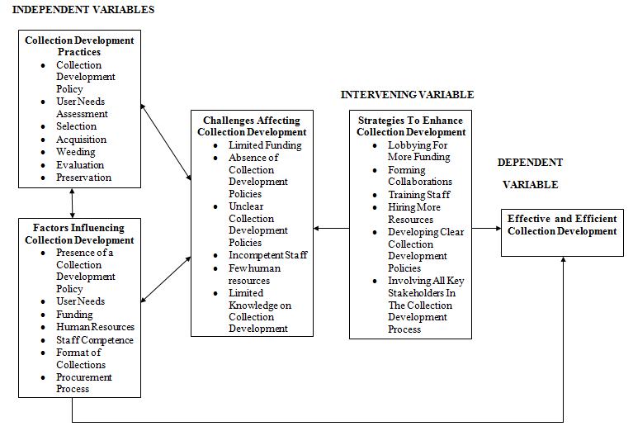
Source: Researcher (2022)

1.10 Justification of the study
Cox, Pinfield and Rutter (2019) and Sejane (2017) acknowledge that academic libraries are undergoing transformative changes as a result of current information and technology trends. While academic libraries in developed countries catch up by incorporating technological changes into their information resources, academic libraries in developing countries catch up at a slower rate (Sejane, 2017). Despite this, academic libraries' role as providers of information resources to their parent institutions' teaching, learning, and research needs has not changed (Florence, Deborah & Rejoice, 2019; Ameyaw & Entsua-Mensah, 2016). This implies that collection development is a critical component in academic libraries because it assists libraries in developing high-quality collections. Collection development practices govern the process of developing collections, making them indispensable in collection development. Given the lack of research on collection development and current collection development practices at the UICT library, the researcher determined that this study was necessary.

1.11 Definition of key operational terms
Collections: Information resources housed in libraries are referred to as collections (Arshad, Ameen, & Arshad, 2021). In the context of this study, collections were defined as UICT's library information resources (both print and non-print).

Collection Development: Arshad et al. (2021) define collection development as the process of developing library collections. The term "collection development" was used in this study to refer to the process by which library collections at the UICT library are developed.

Collection Development Practices: These are the steps taken in the process of developing library collections (Ameyaw & Entsua-Mensah, 2016). These activities include the selection, de-selection, acquisition, and evaluation of library collections, according to the International Federation of Library Associations and Institutions (IFLA) (2020). Collection development practices were used in this study to refer to the set of actions or interventions taken to facilitate collection development at the UICT library.

CHAPTER TWO: LITERATURE REVIEW

2.1 Introduction
To increase a researcher's understanding of the topic or field under investigation, a literature review is conducted (Young, 2017; Snyder, 2019). Conducting a literature review strengthens the theoretical underpinning of the subject of the investigation and justifies the significance of the study. This literature review was guided by the research objectives. In this chapter, the researcher presents existing research on collection development practices in academic libraries; factors influencing collection development in academic libraries; challenges affecting collection development in academic libraries; and the strategies to enhance collection development practices in academic libraries. The chapter concludes by providing the research gap.

2.2 How Collections are Developed in Academic Libraries
Collection development is considered one of the most vital practices in academic libraries. According to Giri, Sen and Mahesh (2015), collection development is a major determinant of the quality of academic libraries. Jan and Ganiae (2019) and Msonge (2015) also note that collection development is the most fundamental aspect of academic libraries. Academic libraries employ a number of activities to develop and manage their collections. Collection development is a continuous activity aimed at building quality updated collections (Shilpa, Uplaonkar, & Badiger, 2018). The study of Levenson and Nichols (2020) adds emphasis to this by noting that it is through collection development that academic libraries are able to provide relevant information resources in a cost-effective way. Therefore, collection development extends beyond just building information resources to providing the appropriate information resources. Giri et al. (2015) point out that collection development practices aim at procuring relevant information resources that meet user needs in academic libraries. The study notes that collection development is a two-way process which involves faculties and librarians. However, this study argues that collection development is multi-faceted considering the librarians, the management of institutions and library patrons including students and faculty members. The study also recognises that some academic libraries also act as public libraries and thus require relevant resources to meet the needs of the public. Despite this, it is argued that collection development practices rely upon communication, both informal and formal to make the collection development process efficacious (Giri et al., 2015; Shilpa et al., 2018; Levenson & Nichols, 2020).
Collections are developed through selection and acquisition. The process of selecting and acquiring resources is usually guided by the collection development policies of academic libraries (Reyes & Devlin, 2020). Under acquisition, user needs are assessed, the existing collections are reviewed to prevent duplications, recommendation lists are sought and all this is compiled to build the collections that ought to be acquired (Giri et al., 2015). The next steps include selecting potential vendors, placing orders with them and following up on the orders to ensure that the right collections are provided (Giri et al., 2015). Giri et al. (2015) reports how library lending and reference sections are some of the useful points in collection development as they show the most sought after collections thus shading light into user needs.

Arshad et al. (2021) report that good collections support academic libraries in meeting the demands of academic institutions. The study also highlights that information organisation in academic libraries begins with collection development. Through collection development, library collections are assessed, developed or weeded out (Arshad et al., 2021). Arshad et al. (2021) also agrees that collection development is not about adding more collections to academic libraries but constitutes a set of practices such as the selection of collections, the acquisition of collections, placing of orders, drafting and implementing collection development policies, deselecting collections, evaluating collections and conducting user needs assessments. The study of Jan and Ganiae (2019) does not majorly deviate from that of Arshad et al. (2021) as it notes that collection development practices include: "a collection development policy, user needs assessment, selection, acquisition, evaluation of collections, weeding and preservation of collections". However, Filson (2018) notes that collecting and managing collections mostly deal with the selection and acquisition of library collections. Selection policies and practices are vital in developing quality collections (Shilpa et al., 2018).

In line with the above studies, the ways of collecting and managing collections involve the:
- Presence of a collection development policy: A collection development policy is considered as a guide that provides a framework for how collections are developed in academic libraries (Jan & Ganiae, 2019). According to Frempong-Kore (2021:2), a collection development policy "outlines the process of selecting materials for a library's collection, the criteria used in selection, weeding, accepting donations, and general library management." This implies that a collection development policy serves as a guide for academic libraries' collection development practices. Despite this, it is stated that most academic libraries lack updated collection development policies or lack collection development policies entirely due to insufficient funds, limited space, the unwillingness of responsible stakeholders, and insufficient library staff (Frempong-Kore, 2021). This demonstrates that, despite their importance, not all academic libraries have collection development policies.

- User Needs Assessment: Librarians and key stakeholders in academic institutions are expected to meet user demands and expectations when developing collections (Arshad et al., 2021). Giri et al. (2015) noted that user needs could be assed from crosschecking facts in the circular and reference sections to understand the nature of collections sought for from users. Arshad et al. (2020) also notes that user needs can be obtained from suggestions in library suggestion boxes. However, this is considered a traditional method. According to Grataridarga's (2019) study, which examines the relevance of user needs assessment in collection development, the process is an initial step and benchmark in collection development. According to the study, academic libraries have different users, and if user needs are not assessed, some users will be excluded. This was demonstrated by a study in which some library patrons reported that the library under study did not have the collections they required (Grataridarga, 2019). Furthermore, Grataridarga (2019) explains that failing to conduct a user needs assessment creates a paradox in which librarians are unsure of which collections to acquire or hold. Given that the collection development process is dynamic and user needs are constantly changing, the study recommends conducting information audits with library users and maintaining a good communication flow between library users and libraries (Grataridarga, 2019).

- Selection Process: Selecting collections to procure is based on user demands, available resources and the selection policies that stipulate how collections should be selected (Shilpa et al., 2018). For example, the study of Giri et al. (2015) observed that most academic libraries still preferred print books compared to e-books even in today's information era where there is information explosion. Selection is defined by Shou and Kimaro (2021, p.2) as "the process of selecting library materials." According to the study, the selection process must come before the acquisition process. The study found that the selection process is influenced by the needs of the library's patrons (Shou & Kimaro, 2021).

- Acquisition Process: The selection process guides the acquisition process (Giri et al., 2015). The acquisition process includes the steps to be taken to procure books including potential suppliers, types of books, shipping costs, funding modes, among others (Filson, 2018). Reyes and Devin (2020) note that subject expertise and user demands drive acquisitions in academic libraries. Acquisition, according to Shou and Kimaro (2021), is the process of acquiring library collections. According to the study, academic libraries frequently consider "curriculum support, cost, standard source availability, faculty research report, graduate student research support, subject representation, collection continuity, and inter-institutional agreements" when acquiring library collections (Shou & Kimaro, 2021, p.2). Finally, the study confirms that library collections can be obtained through gifts, exchange, or purchase (Shou & Kimaro, 2021). This implies that academic libraries have options for acquiring library collections.

- Evaluation Process: Library collections have to be evaluated to ensure that they are filling the information needs of academic institutions (Jan & Ganiae, 2019; Arshad et al., 2021). This includes reviewing their content, frequency of usage and ongoing trends or global changes. Collection evaluations, according to Msonge (2016), help librarians understand what collections they have and how they meet their collection development goals. The study also mentions that librarians can use user-centered evaluation, physical assessment, specific subject support, and citation analysis to evaluate their collections (Msonge, 2016). Librarians improve their capacity for successful collection and financial management by evaluating their collections. Collection evaluation also assists librarians in determining the adequacy and quality of their collections, as well as whether they meet user needs. Nelson et al. (2020) also point out that evaluating collections results in the selection of appropriate deselection criteria in order to have collections that are current, relevant, and accurate.

- Weeding Process: Weeding is conducted to remove library collections that are no longer relevant. These could be outdated collections, collections for phased out courses or collections with information which is contested (Jan &Ganiae, 2019). Weeding is a beneficial practice in librarianship because it reduces the number of collections that libraries maintain (Nelson et al., 2020; Dushu, 2016). This means that weeding makes room for new collections. Weeding is a continuous and ongoing process that ensures that useful library collections are available to library patrons (Dushu, 2016). According to Dushu (2016)'s research, weeding should be covered by the library's collection development policy because it can be contentious. As a result, the collection development policy should spell out exactly what weeding entails.

- Preservation and Conservation Process: When collections are developed, measures have to be taken to ensure that they are preserved and conserved. The preservation process includes steps such as ensuring that collections are kept in good conditions to guarantee their longevity (Jan &Ganiae, 2019).Preservation and conservation are essential for library collections, according to Alex-Nmecha and Okoro (2020), because library collections can only be retrieved when they are in good condition. This study agrees because good information resources are important for providing quality service in libraries. Standard preservation and conservation policies are required to improve the preservation and conservation process (Alex-Nmecha & Okoro, 2020). These policies can be implemented independently or as part of the collection development policy.

2.3 Factors Influencing Collection Development in Academic Libraries
A number of studies have propounded on the factors that influence collection development in academic libraries. In Reyes and Devlin (2020), librarians were asked to rank the factors that influence collection development in academic libraries. User preference was ranked first while the second factor was the course (Reyes & Devlin, 2020). This indicated that in the development of collections for academic libraries, the preferences of users had a significant influence in the collections that were selected or acquired. Secondly, given that the context is academic libraries, the courses provided and their prerequisites in terms of reading materials also have an influence on the collections developed in academic libraries. Surprisingly, the study reported that collection development policies were not considered as major factors in collection development as 49% of the librarians selected neutral. Other factors examined included the price of the collections, the availability of the collections, the accessibility of the collections, the number of users, the urgency of request, platforms for e-books, preservation requirements and license and ownership (Reyes & Devlin, 2020).

In the study of Arshad et al. (2021), user feedback was also given the most priority in the collection development process. The participants ranked users' needs analysis second in the collection development process of academic libraries. The findings are not much different from those reported by Reyes and Devlin (2020) who ranked user preference first in the collection development process. Arshad et al. (2021) stressed that by conducting a user needs analysis, librarians are in better position to provide appropriate collections to academic institutions. This indicates how analysing user needs greatly affects the collection development process. Censorship was also another factor provided by Arshad et al. (2021). The study reported that some academic libraries had restrictions on collecting controversial collections or those from controversial authors. Most of these collections were political or religious (Arshad et al., 2021). Additionally, the usage patterns of collections also influenced the collection development process. Librarians monitor the circulation of collections as a way of measuring usage statistics in academic libraries, which gives them a picture on the most sought after collections (Arshad et al., 2021; Jan & Ganiae, 2019). Another study by Kamau and Elegwa (2021) reported that collection development was influenced by collection development policies, budget allocations, user needs, staff competence, cooperation among faculty members and procurement schedules. These were the factors that influenced collection development at the University of Nairobi Library. However, Rubangakene (2019) observed that the factors influencing collection development at Gulu University Library were the goals for collection development, collection development policies and procedures, user needs, collection development budgets, collection evaluation, selection of reading materials, format of selected reading materials, access and ownership issues, cooperative collection development, resource-sharing programs and legal issues pertaining collection development. Other factors which the study identified included the available funding, human resources, goals for collection development and international and national standards (Shilpa et al., 2018; Levenson & Nichols, 2020).

2.4 Challenges Affecting Collection Development in Academic Libraries
Despite the importance of collection development in academic libraries, academic libraries encounter some challenges which affect their collection development process. These challenges include:

2.4.1 Budget challenges
Enough funding is needed to in collection development, however, most academic libraries are constrained by limited funds which affects their acquisition process (Levenson & Nichols, 2020; Florence et al., 2019). Additionally, there are few opportunities for cost-sharing and equity due to limited partnerships which affects the collection development process for academic libraries (Levenson & Nichols, 2020). Other challenges that affect budgets include budget cuts, currency fluctuations and market changes on book prices (Mwilongo et al., 2020; Kamau & Elegwa, 2021).

2.4.2 Determining the quantity of collections required
Giri et al. (2015) note that the collection development process is affected by the required quantity of collections. Most academic libraries have no approach to determine the number of copies needed for particular collections and thus either stock too many copies or too few copies (Giri et al., 2015). This affects their acquisition budgets and usage patterns.

2.4.3 Lack of subject specialist librarians
While most academic libraries in developed countries have subject specialist librarians, the opposite is true for those in developing countries. This affects the ability of librarians to understand user needs and expectations (Giri et al., 2015).

2.4.4 Traditional processes for collection development
Giri et al. (2015) further reports that most academic libraries follow a rigid process for collection development which follows a hierarchical path. This implies that directives come from the heads of faculties, then respective departments and end with the librarians. This implies that users are often ignored and yet they are the ones in need of the collections.

2.4.5 Limited staff
Most academic libraries have few librarians with other duties to perform (Farkas, Hinchliffe & Houk, 2015; Giri et al., 2015). This implies that they lack time to devote to the collection development process which affects collection development in academic libraries. Inadequate staff also result in backlogs and delays in this collection development processes (Mwilongo et al., 2020; Kamau & Elegwa, 2021).

2.4.6 Weak ties between library sections
Giri et al. (2015) notes that library sections such as the circulation and reference sections can provide a glimpse of user needs. However, there are often weak ties among sections which limits the ability of librarians to take advantage of them to understand user needs. The lack of cooperation between key stakeholders also subsequently affects the process of collection development in academic libraries (Kamau & Elegwa, 2021).

2.4.7 Inadequate training of librarians
Most librarians are not trained in collection development and thus do not understand the tasks and complexities involved (Giri et al., 2015; Farkas et al., 2015). This limits collection development in academic libraries.

2.4.8 Lack of collection development policies
While the study of Reyes and Devin (2020) noted that collection development policies are not important, Jan and Ganiae (2019) report that libraries without collection development policies often have flaws in the collection development process. It is also reported that some academic libraries have outdated and unclear collection development policies which affect how collections are developed (Kamau & Elegwa, 2021). This is coupled with librarians who do not adhere to collection development policies (Kamau & Elegwa, 2021). All these affect the collection development process.

2.5 Strategies to Improve Collection Development in Academic Libraries
According to Levenson and Nichols (2020), collaborations are important in enhancing collection development in academic libraries. The study propose collaborative collective management where academic libraries can tap into today's interconnected, user-centered and relational resource environment to develop collections. Another study recommends introducing training and educational programs to enhance the knowledge of librarians in collection development practices (Yakubu et al., 2022). The same study recommends conducting user needs assessments given that the needs of library patrons changes with time (Yakubu et al., 2022). This also implies regularly reviewing collections to ensure the efficiency of collection development. According to Jan and Ganiae (2019), libraries have to prune or weed collections to remove unnecessary collections, create space for new acquisitions and to increase circulation rates.

Kamau and Elegwa (2021) also recommend designing and implementing a collection development policy. The study also suggests reviewing collection development policies regularly to keep up with trends and user needs; motivating all library patrons including students to participate in the collection development process; encouraging library staff to keep up with emerging trends; soliciting collections from both local and international publishers to widen the variety of collections; lobbying for more funding and book aids; and interlibrary exchanges (Kamau & Elegwa, 2021). Mwilongo et al. (2020) recommend introducing professional development programmes for librarians and designing comprehensive collection development policies. On the other hand, Shilpa et al. (2018) recommends developing a well-planned system for collection development, being mindful of the goals of collection development, and drafting long-term policies for collection development since collection development is a continuous process.

2.6 Research Gap
The literature reviewed highlighted the essence of collection development, collection development practices, factors that influence collection development, challenges that affect collection development and strategies to enhance collection development in academic libraries. Despite being comprehensive enough, no study was found examining the above with a focus at UICT. This study thus sought to fill this knowledge gap by examining the collection development practices at UICT.

CHAPTER THREE: METHODOLOGY

3.1 Introduction
The methodology section presents the systematic procedural framework followed to conduct a study (Mohajan, 2018). It shows how explicitly, logically and systematically a given research has been conducted. This chapter presents the area of study, research design, research approach, population of the study, the sample size, data collection methods and instruments, data quality control, analysis and presentation, limitations and delimitations of the study and the ethical considerations.

3.2 Area of the study
The study was conducted at the library of Uganda Institute of Information and Communications Technology, which is located at Plot 19-21, Port Bell Road, P.O. Box 7187, Nakawa, Kampala (UICT, 2022). This was selected as the area of the study because the UICT library serves Uganda's only government institution that offers specialized training at the certificate and diploma levels. This implies that its collections are vital for the institution to achieve its mandate.

3.3 Research design
A research design is a plan used to guide a researcher's search for the most reliable, impartial, accurate and cost-effective solutions to research questions (Kumar, 2019). This makes it a crucial component of any study as it makes it easier for research to be conducted smoothly within the least amount of time and effort (Kothari, 2019). For this study, a case study research design was selected, Mohajan (2018) defines a case study research design as one that explores events, people or situations in-depth. A case study research design facilitates the achievement of a comprehensive description of a particular case. A case study research design was selected to gain an in-depth understanding and insights on the collection development practices at the UICT library.

3.4 Research Approach
This study adopted a qualitative research approach. According to Mohajan (2018), a qualitative research approach is one that is inductive in nature and explores meanings and insights in a given situation. Qualitative research approaches do not consist of empirical calculations or statistical analyses and they are composed of multiple realities given that they study people, events or situations (Rahman, 2017). The researcher adopted a qualitative research approach to describe and interpret the collection development practices at UICT Library paying attention to the objectives of the study. A qualitative research approach facilitated in gaining insights into the perceptions that the study participants had concerning collection development at the UICT library.

3.5 Study Population
A study population is composed of the entire cases or groups of people a researcher is interested in studying (Casteel & Bridier, 2021). This study targeted faculty heads and their assistants, university librarians and student representatives from diploma and certificate courses at UICT. The population was selected due to its expected contribution to the study. The total target population was composed of 15 people and it is broken down as follows:

Table 3. 1: Study Population
Designation | Number
Librarians | 2
Faculty Heads | 2
Faculty Assistants | 2
Student Representatives | 9
Total | 15
Source: Researcher (2022)

3.6 Sample Size
Busetto, Wick and Gumbinger (2020) note that sampling in qualitative studies is about choosing objects that are deemed relevant for the study to be present in the sample. The study further notes that in qualitative studies, researchers pre-define the kind of participants they want and these could be as less as one to thirty study participants (Busetto et al., 2020). Therefore, all the 15 study participants were purposively selected as the sample size for the study. Purposive sampling was used because they were perceived to be knowledgeable about the state of collection development at the UICT library and would therefore provide informative findings to inform the study.

3.7 Data Collection Methods
Data collection refers to the process followed in collecting data. Considering that this study was qualitative, the researcher adopted qualitative data collection methods as elaborated below:

3.7.1 Document Review
Through a document review, the researcher reviews or analyses relevant publications which can either be internal or external (Busetto et al., 2020). The researcher used a document review to analyse external documents on collection development practices. These included documents published by IFLA, American Library Association and the Library and Information Science Education Network. The researcher expected to review some internal documents as well such as the collection development policy for UICT library, however, by the time of conducting the field study, the head librarian who was in possession of the document was not available. Therefore, the researcher did not review any internal documents on collection development as anticipated.

3.7.2 Semi-Structured Interviews
Interviews are exchanges between an interviewer and interviewee. They can be used to gain insights into someone's experience or opinion (Busetto et al., 2020). Semi-structured interviews were conducted by the researcher with 14 of the 15 study participants. One of the study participants was on leave by the time of conducting the interview and therefore could not be interviewed. These consisted of open-ended questions guided by an interview guide which was structured based on the objectives of the study.

3.8 Data Quality Control
According to Lê and Schmid (2020), researchers ought to establish mechanisms to ensure that their research efforts can be trusted throughout the whole research process including data collection. Data quality control is a strategy that involves controlling how data is collected (Kumar, 2019). This can be achieved through two main technical criteria, which is reliability and validity (Creswell, 2016).

3.8.1 Validity and Reliability
Validity in qualitative research means “appropriateness” of the tools, processes, and data, while the essence of reliability for qualitative research lies with consistency (Yin, 2018). Validity was guaranteed by sharing the data collection instruments with the research supervisors for a second opinion on their relevance to the study. The research supervisors provided guidance on how to improve the data collection instruments. For example, it was advised that the data collection instruments should be guided by the research objectives. This had not been considered initially. However, with the advice provided, they were re-designed and developed in line with the research objectives. As for reliability, the researcher ensured to provide all the necessary steps followed in conducting the study to ensure that the research can be reproduced with similar findings generated. These included the methodology followed right from the way the research was designed to how it was analysed and presented, and the ethical considerations considered. It is expected that if another researcher follows the same steps and conducts this research within the same context or setting, they will come to the same findings or results.

3.9 Data Analysis and Presentation
Content analysis was used as a way to analyse the qualitative data. This included reading the information written down, describing and highlighting key information, studying the characteristics and qualities of the information acquired, relating the results to the objectives of the study and drawing conclusions based on the findings. According to Mohajan (2018), qualitative data analysis depends on the volume of data generated and the research design. Given that this was a case study research design, the researcher ensured to understand the collected data in line with the case study and to analyse patterns that were illuminated during the data analysis process. The findings were presented by highlighting the major findings and then providing thorough descriptions of each findings using texts, examples and verbatim.

3.10 Ethical Considerations
Rahman (2017) points out how adhering to ethical rules is important for researchers. The study highlights some myriad issues involved in ethical considerations. For this study, the researcher sought for informed consent from the research participants, maintained confidentiality of the results and the anonymity of the study participants, ensured that no harm came to the study participants for participating in the study, treated all the study participants equitably and adhered to academic integrity by properly acknowledging all secondary sources used. Informed consent was obtained by asking the study participants to sign a consent form. The confidentiality and anonymity of the study participants were upheld by not disclosing the personal identities of the study participants and withholding any self-identifying or confidential information. The study participants were accessed in safe environments to ensure that no harm came to them and they were treated equally. Lastly, all secondary sources used were properly cited and referenced and a plagiarism test was taken using TurnItIn software to ensure that the study was free from plagiarism.

3.11 Limitations and De-Limitations of the Study
Some study participants were very busy and could not honour their appointments. This affected the response rates of the study. However, the researcher tried to create more room to proceed with new appointments with them which worked for some but not for others. Some of the study participants also expected to be rewarded for their participation in the study. However, the researcher explained to them that this study was for purely academic reasons and thus no rewards would be provided.

CHAPTER FOUR: PRESENTATION AND DISCUSSION OF THE FINDINGS

4.1 introduction
This chapter presents the study findings from the field in two sections. The first section contains the responses and demographic information of the study participants while the second section contains the key findings from the field presented using the objectives of the study as key themes for the study.

Part 1: Responses and demographic information of the study participants

4.2 Responses received
The researcher received responses from 14 people who included the assistant librarian, representatives from the faculty and representatives from the student fraternity pursuing the various diploma and certificate courses offered by UICT under their two departments: Department of ICT & Engineering and the Department of Management. The study participants were given codes based on their designation and genders in the following order: Designation Gender. This information combining the designation, gender, number and codes is presented below:

Table 4. 1: Responses received
Designation | Gender | Number | Code
Librarians
Assistant Librarian | F | 1 | ALF
Faculty Representatives
Assistant Head of Faculty (ICT) | M | 1 | AHFIM
Head of Faculty (ICT) | M | 1 | HFIM
Assistant Head of Faculty (Management) | M | 1 | AHFM
Head of Faculty (Management) | M | 1 | HFM
Student Representatives
Student (Dip. in Electrical & Electronics Engineering) | M | 1 | SDEEEM
Student (Dip. in Information Technology in Business) | F | 1 | SDITF
Student (Dip. in Business Administration) | M | 1 | SDBAM
Student (Dip. in Procurement and Logistics) | M | 1 | SDPLM
Student (Dip. in Records and Archives Management) | F | 1 | SDRAMF
Student (National Certificate in Records Management) | M | 1 | SNCRIMM
Student (Certificate in Information Technology) | F | 1 | SCITF
Student (Diploma in Information Technology in Science) | M | 1 | SDITM
Student (Diploma in Computer Technology) | M | 1 | SDCTM
Source: Researcher (2022)

From the information presented above, interviews were conducted with one assistant librarian, four representatives from the faculty and nine representatives from the student fraternity. All the study participants had different designations, with the faculty staff either coming from the Department of ICT or Management. The same applied to students who affiliated to one of the two departments offering different diploma and certificate courses at UICT. In total, the study had four females and ten males. This was attributed to the high number of male staff in the faculties compared to female staff.

4.3 Age of the study participants
Six study participants (the assistant librarian, representatives from the faculty and one student) were aged between 31-40 years while the rest (all other students except one) were aged 30 years and below. The age of the study participants was found relevant to determine whether they would ably inform the study given that this was a qualitative study which aimed at obtaining quality findings to inform the study.

4.4 Years worked at UICT
The researcher asked the assistant librarian and representatives from the staff faculty the duration for which they had worked at UICT. One study participant had worked for 1-5 years while four study participants had worked for 6-10 years. This showed that the assistant librarian and faculty staff were well-informed about what happens at UICT and could ably inform the study.

4.5 Years studied at UICT
The student representatives from each course were asked for how long they had studied from UICT. Three study participants had studied from UICT for two years while six study participants had studied from UICT for one year. Given that UICT offers diploma and short courses, the most a student can pursue a course is for two years while certificate courses generally run for a year and less than that. The imbalance in the years studied at UICT was attributed to the fact that most students in their final year do not take up leadership positions while this study targeted students of varying courses who served on the guild.

Part 2: Presentation of the study findings

4.6 How collections are developed at UICT
The first objective of the study was to find out how collections are developed at UICT. The researcher sought to understand if UICT had a collection development policy, conducted user needs assessment and had procedures for the selection, acquisition, weeding, evaluation and preservation of collections. The findings are presented below:

4.6.1 Collection development policy
The study established that it was only the assistant librarian who was aware of the institute's collection development policy. All other study participants had no idea about the collection development policy or what it entailed. Some of the faculty staff mentioned things such as "maybe" or "I think so" when asked if UICT had a collection development policy. However, the assistant librarian (ALF), noted that:
UICT has a collection development policy which caters for print (books, journals, newspapers and periodicals) and non-print (electronic resources). The collection development policy has procedures to be followed in collection development process such as forming small committees to handle different activities. It also talks about collection development; the legal authority and staff responsibility for selection, identification of users and the community served, mode of selection and guide for selection and collection evaluation.

According to AFHIM, a faculty staff:
I am not aware of the collection development process nor if UICT has a collection development policy. I do not even know if the department has a library coordinator for collection development.

AFHIM's views were supported by SLIM, another faculty staff who noted that:
I am not aware of the collection development process nor UICT's collection development policy.

The same views were provided by AFHM and FHM, both faculty staff as well. In fact AFHM said that UICT had no collection development policy. When it came to the student representatives, all of them as well had no idea of UICT's collection development policy nor the collection development process. All the student representatives said they had never been involved in the collection development process at UICT. Based on these views, the study concluded that UICT's collection development was one-sided with only key stakeholders affiliated to the library having knowledge about the process of collection development.

According to a document published by the International Federation of Library Associations and Institutions (IFLA) entitled: Guidelines for a Collection Development Policy Using the Conspectus Model, it is acknowledged that despite the primary task of libraries being to select, maintain, and provide access to relevant and representative information resources, most libraries lack collection development policies or have outdated collection development policies. This means that their collection development policies are not representative of the significant changes that keep happening from time to time. The document echoes that collection development policies act as policy statements that serve different functions which extend beyond being merely tools for selecting materials. This document draws emphasis on the importance of collection development policies. The document also notes that the collection development policy should guide library staff and affiliated stakeholders in making collection development decisions (IFLA, 2019). From the assistant librarian (ALF), it was established that UICT has a collection development policy. However, all other study participants are not aware of the collection development policy. This reflects a gap in collection development as the process of collection development is mostly one-sided with the librarians and perhaps top management being the key decision-makers.

4.6.2 User needs assessment
When it came to user needs assessment, ALF pointed out that user needs were analysed during the collection development process. The faculty staff were asked if they have ever participated in the collection development process and all of them agreed. They shared that they have ever been asked to send titles of collections the library should procure in their areas of study. AFHIM noted that:
I once worked with the librarian to procure new collections. She sent an email asking lecturers to identify titles to be purchased in our areas of study.

The same assertions were made by FHIM, AFHM and FHM. The study concluded that faculty staff were involved in the collection development process to some extent. However, when it came to the students, none had ever participated in the collection development process whether individually or with fellow students. As a result, this presented some challenges. All student participants reported that they have ever failed to access preferred collections. They also noted that UICT has few collections with most being outdated. According to SDEEM:
I prefer both print and electronic resources but I think my needs as a student are not considered in the collection development process because many times I never access the collections I want. UICT has very few collections.

Another student, SNCRIMM, who attended weekend classes said:
Weekend students have challenges of accessing the library and therefore, we barely use the library. The institute has electronic resources but we did not receive training on how to use the e-library so we cannot access them. I think user needs are not met.
These responses showed that the collection development process ignored the needs of the students by not considering them, and therefore, they were unhappy with the available collections. The study reviewed a document published by the United Nations Educational, Scientific and Cultural Organization (UNESCO) about library statistics. The document defines a library user as one who utilizes a library's services. Additionally, it notes that libraries of tertiary institutions primarily serve students and teachers, and may also be open to the general public. However, in spite of this, UICT has primarily ignored students, who are part of the library users in its collection development process.

4.6.3 Selection
According to the assistant librarian (ALF), the selection process was guided by the collection development policy. This involved putting up a committee to handle the selection process. However, all the faculty staff shared that they had never been involved in the selection process. The same assertion was made with the students who are entirely not involved in the collection development process. A document reviewed by the Library and Information Science Education Network on Collection Development which was published in 2018 reports that the selection of library collections is a joint responsibility of the teaching faculty and library staff. This implies that the teaching faculty and library staff are the primary stakeholders in the selection of collections to ensure that the library has balanced collections. However, at UICT, the teaching faculty staff were left out in the selection process although they were involved in the user needs assessment.

4.6.4 Acquisition
The assistant librarian (ALF) observed that the acquisition process at UICT was also guided by the collection development policy. ALF noted that collections were developed annually. While the faculty staff agreed that collections at UICT were developed annually, they were not specifically sure about how collections were acquired. Some mentioned buying/purchasing, others mentioned donations while some said they were not sure. The students were entirely clueless about how collections were acquired. All of them just mentioned that they were acquired by buying/purchasing but were uncertain. These assertions were anticipated given the fact that they were left out in the collection development process. The document by the Library and Information Science Education Network on Collection Development published in 2018 notes that collections are acquired through purchase, which is the primary method for collection development; gifts/donations; institutional membership; deposit system; or exchange. Therefore, there are various ways in which collections can be acquired.

Figure 4. 1: The researcher interviewing one of the faculty staff
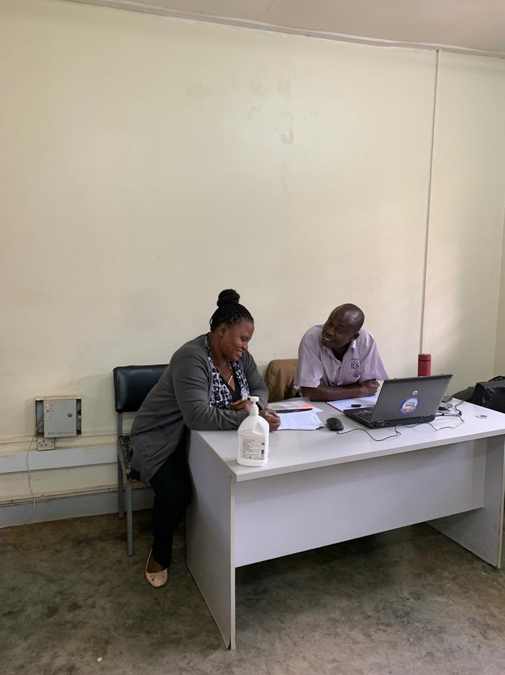
Source: Researcher (2022)

4.6.5 Weeding and Evaluation
The study also sought to find out how weeding and evaluation were conducted. The assistant librarian said that collections were evaluated from time to time. However, weeding was rarely conducted. This was asserted by students who observed that the UICT library had many outdated collections. For example, a student SDITF said that:
The library has few copies and most of them are outdated.

The same assertion was made by other students and the faculty staff. This showed that weeding was rarely carried out. Collection maintenance and weeding, according to the American Library Association, are critical components of collection management because they ensure that libraries have accurate and up-to-date collections. They also ensure that library users can access the available collections. Therefore, the UICT library has to consider weeding as a way of ensuring quality collections.

4.7 Factors that influence collection development at the UICT library
The second objective of the study was to determine the factors that influence collection development at the UICT library. The researcher asked the study participants to share the factors that influenced collection development at the UICT library. These factors are presented in sub-themes as:

4.7.1 Budget
The study participants shared that the available budget influenced collection development at the UICT library. ALF was the only participant who was aware of how much was allocated to collection development at UICT but she also mentioned the budget as key factor that influenced collection development at UICT. This was also associated with rising costs of collections which resulted in budget constraints.

4.7.2 Collection development policy
All other study participants except ALF mentioned the absence of a collection development policy as a factor that influenced collection development. However, ALF previously noted that the UICT library had a collection development policy. It was concluded that this was mentioned because other study participants had no knowledge about the presence of a collection development policy at the UICT library.

4.7.3 Key stakeholders in the collection development process
It was established that the key stakeholders in the collection development process also influenced collection development at the UICT library. ALF noted that the key stakeholders in the collection development process were the library's governing body, the library staff and department heads and users. However, like earlier established, most users were left out in the collection development process.

4.7.4 Involvement of users
All study participants except ALF noted that they were not involved in the collection development process. Even the faculty staff reported that they were rarely involved in the collection development process. As a result, collections at the UICT library were not balanced.

4.7.5 Quality of staff
ALF noted that the quality of staff influenced the collection development process. According to ALF, some staff were not informed and could not provide the needed titles which affected the collection development process.

Figure 4. 2: The researcher having a brief discussion with the student representatives after the interviews
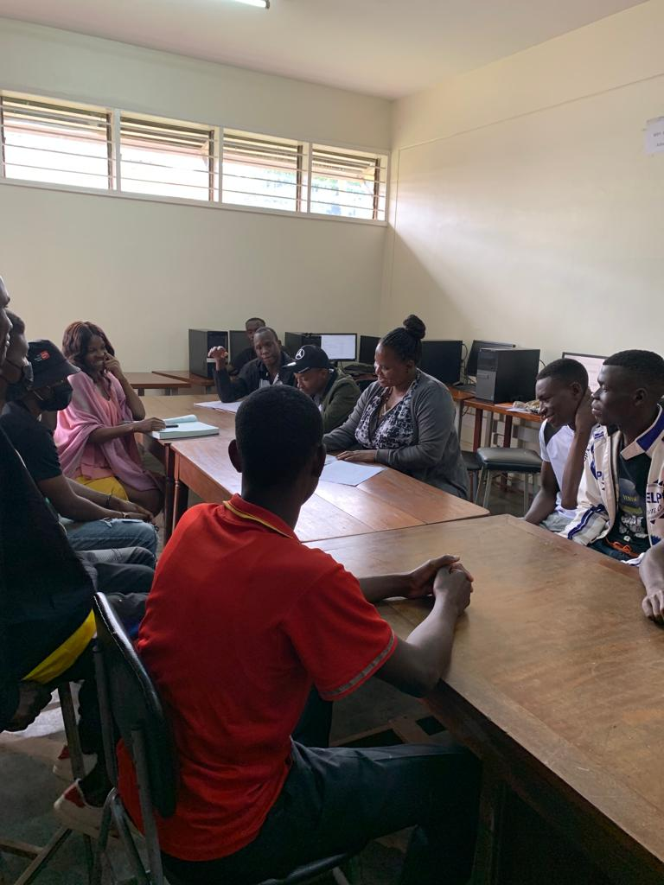
Source: Researcher (2022)

4.8 Challenges affecting collection development at the UICT library
The third objective of the study was to find out the challenges affecting collection development at the UICT library. The researcher asked the study participants to share the challenges affecting collection development at the UICT library. The challenges provided are shared in the sub-themes below:

4.8.1 Inadequate budgets
The study participants mentioned that collection development was limited by budget constraints. According to ALF, inadequate budgets affected collection development at the UICT library. At the same time, some of the information resources were costly.

4.8.2 Lack of collection development training
ALF shared that library staff had no training in collection development. This was a limitation as it influenced the way they approached collection development yet they were among the key stakeholders in collection development.

4.8.3 Lack of user needs assessments
User needs were rarely assessed and students were completely cut off from collection development yet they were equally library users. Therefore, this affected collection development.

4.8.4 Inadequate collection development policies
ALF shared the collection development policy did not cover some subjects and therefore, it guided the collection development process of only particular subjects. There was thus a need to review the existing collection development policy.

4.8.5 Low levels of ICT
While UICT had an e-library, most staff and students had limited ICT skills and rarely used the e-library which had collections that could be obtained simultaneously. This also affected collection development.

4.8.6 Lack of support from top management
ALF and the faculty staff shared that their recommendations were rarely taken into consideration. According to ALF, due to financial constraints, the management prioritized other needs over collection development. AFHIM noted that:
Even if you make suggestions to enhance collection development, they are never implemented.
This showed that staff recommendations on collection development were ignored.

4.8.7 Few and out-dated copies
Study participants complained about few and out-dated copies which did not meet their user needs. This was a key observation made by faculty staff and the students. All the students that participated in this study failed to access a collection they needed at one time. SDPLM also reported that some subjects were not catered for. This was established as an outcome of the collection development policy leaving out some subjects as shared by ALF.

4.8.8 High costs of internet and unstable internet
Despite having an e-library, the costs of internet were high and the internet at UICT was unstable which prevented library users from accessing the e-library. This challenge was presented by the faculty staff and students.

4.9 Strategies to improve collection development at the UICT library
The last objective of the study was to obtain recommendations for improving collection development at the UICT library. The study obtained different recommendations from the study participants which are presented below according to each participant.

4.9.1 Assistant librarian
ALF recommended training staff involved in the collection development process; increasing the budget for collection development; ensuring that the allocated funds are used for their purpose and constantly reviewing the CDP to fit with the existing changes.

4.9.2 Faculty staff
AFHIM recommended considering staff recommendations, increasing the collection development budget and obtaining more digital copies. FHIM recommended increasing the library budget and taking into consideration staff suggestions. AFHM recommended formulating a collection development policy and budgets tailored towards collection development. Lastly, FHM recommended increasing the library budget, utilizing the students' library fees to their expectations and involving library users.

4.9.3 Student representatives
SDEEM recommended involving all stakeholders, increasing the collection development budget and training staff that implement collection development. SDITF recommended utilizing the library fees students pay to purchase collections. SDBAM recommended acquiring more collections. SDPLM recommended increasing the budget and utilizing the library fees well. SDRAMF recommended improving the internet services so that the internet is stable. SNCRIMM recommended involving students who are the most users of the information resources. SCITF recommended putting more emphasis on the use of online resources. SDITM recommended using library fees paid to acquire more collections and SDCTM recommended involving students in the collection development process.

4.10 Discussion of the findings
This study aimed at examining the current collection development practices at the UICT library to see if they were effective in assisting the library in building quality collections. The study's objectives were: i) to find out how collections are developed at the UICT library; ii) to determine the factors that influence collection development at the UICT library; iii) to investigate the challenges affecting collection development at the UICT library; iv) and to make recommendations for strategies to improve collection development at the UICT library. This section discusses the major findings of the study based on the objectives of the study.

4.10.1 How collections are developed at the UICT library
It was established that although the UICT library had a collection development policy, it was only known to the librarians, and therefore, the faculty staff and student fraternity did not know of its existence. It was also established that students were not involved in the collection development process although staff participated in the collection development process at some point through providing titles. However, despite this, the staff complained that their suggestions were never considered. The assistant librarian also shared that their recommendations were not considered. Therefore, collection development generally depended on the management's priorities. The study of Jan and Ganiae (2019) that looks at the trends in collection development practices notes that most academic libraries possess numerous flaws in the way they develop their collections by ignoring collection development policies and user needs yet their purpose is to serve the needs of the library users. A document published by the Library and Information Science Education Network in 2022 notes that the primary purpose of collection development is to meet the information needs of the users. This implies that in collection development, library users come first. However, this is not the case with the current collection development practices at the UICT library. At the UICT library, collections are developed with minimal input from the users and the students are totally left out in the collection development process. According to Ameyaw and Entsua-Mensah (2016), when user needs are ignored, their expectations are not met which leads to low levels of satisfaction and discourages them from accessing libraries. Therefore, to prevent this from happening, the UICT library management has to start considering all its users in the collection development process.

4.10.2 Factors that influence collection development at the UICT library
The study established that collection development was influenced by the budget, the key stakeholders involved, ICT training, involvement of users and quality of staff. Kamau and Elegwa (2021) concur that collection development is affected by user demands, budget allocations, staff quality and also add on the collection development policy, library consortium and the Public Procurement and Asset Disposal Act for public libraries. The study of Rubangakene (2019) also argued that user needs, collection development budgets and policies and procedures also affected collection development. The same findings were reported by Sanjay (2016). Given that collection development does not emanate from vacuum, these factors have a direct bearing on how collections are developed in academic libraries. Therefore, they can act as facilitators or limitations to collection development and thus need to be managed.

4.10.3 Challenges that affect collection development at the UICT library
The challenges that affect collection development at the UICT library were identified as inadequate budgets, lack of collection development training, lack of user needs assessments, inadequate collection development policies, low levels of ICT, lack of support from top management, few and out-dated copies, high costs of internet and unstable internet. Galbo (2020) concurs with some of these findings by observing that restrictive budgets greatly affect collection development processes. However, the same study notes that without developing the right collections, academic libraries are at risk of having under-used collections, which will discourage stakeholders involved in collection development from developing collections (Galbo, 2020). The study brings out a new concept of the risk of having poor quality collections thus providing a justification for why academic libraries such as the UICT library should develop the right collections. On the other hand, Chen (2017), notes that collection development is about managing changes and therefore, the constraints that affect collection development do not facilitate change management. This results in possessing out-dated collections or having collections that do not meet user needs and thus affect the collection development process.

4.10.4 Strategies to improve collection development at the UICT library
The last objective of the study aimed at finding out the strategies to improve collection development at the UICT library. The study participants provided different recommendations which included: increasing budget allocations, utilizing library fees for collection development, considering staff recommendations, reviewing the collection development process, involving library users in the collection development process, improving internet services and putting more emphasis on the use of online resources. According to a document published by the American Library Association on Collection Development in 2018, collection development is conducted to provide the appropriate collections to library users. This statement draws insight into the relevance of library users in collection development. It also puts library users as the major stakeholders in collection development, which implies that the activities of collection development should revolve around them. This implies that considering the views of library users is important in collection development and therefore, the UICT library management staff should put user needs first when developing collections, which also includes putting their recommendations into consideration.

4.10.5 Conclusion
This study aimed at examining the collection development practices at the UICT library to ascertain whether they were effective or not. Based on the findings from the field study, it can be deduced that the current collection development practices at the UICT library are not effective because they do not consider the library users who are the main patrons in librarianship. This was also reflected in the fact that the study participants reported failure to access collections they required and the library having out-dated collections. Therefore, there is need to conduct comprehensive user needs assessments, which are not one-sided but consider all UICT library users.

CHAPTER FIVE: SUMMARY OF THE FINDINGS, CONCLUSIONS AND RECOMMENDATIONS

5.1 Introduction
This chapter presents the summary of the findings and conclusions based on the research objectives. It also presents the recommendations and areas for further research.

5.2 Summary of the findings

5.2.1 How collections are developed at the UICT library
The study established that the UICT library had a collection development policy although it was not known by the faculty staff and student representatives. The study also established that the UICT library did not consider students in its user needs assessment. The faculty staff and students were not aware about the selection, acquisition, weeding and evaluation processes of the UICT library. However, the assistant library shared that these processes were guided by the collection development policy.

5.2.2 Factors that influence collection development at the UICT library
It was revealed that collection development was influenced by the budget, quality of staff, involvement of users, the key stakeholders involved (library staff and library management) and ICT training. It was agreed that these factors either enhanced collection development or affected it.

5.2.3 Challenges that affect collection development at the UICT library
The study identified the challenges that affect collection development at the UICT library as inadequate budgets, lack of user needs assessments, unclear collection development policies, low ICT literary levels, lack of top management support, few and outdated copies, high internet costs, unstable internet costs, failure to consider staff recommendations and lack of collection development training for library staff.

5.2.4 Strategies to improve collection development at the UICT library
The study participants recommended increased budget allocations, utilizing library fees for collection development, considering staff recommendations, reviewing the collection development process, involving library users in the collection development process, improving internet services and putting more emphasis on the use of online resources.

5.3 Conclusions

5.3.1 How collections are developed at the UICT library
It was concluded that the collection development process at the UICT library was one-sided as students were not included in the collection development process, and staff played a limited role despite being major library users. This affected the process of developing and managing collections at the library. The study deduced that user needs assessment had a major role to play in the development of quality collections and therefore, the UICT library management had to include all its library users in the collection development process by conducting a comprehensive user needs assessment. Doing this would improve its collection development process.

5.3.2 Factors that influence collection development at the UICT library
The study concluded that these factors could either act as enablers or barriers to collection development at the UICT library depending on how they were managed. However, important to note is the fact that the primary aim of collection development is to provide appropriate information needs, and therefore, this should be the focus of those in charge of collection development. Therefore, the enabling factors have to be reinforced while the barriers have to be addressed to improve collection development at the UICT library.

5.3.3 Challenges affecting collection development at the UICT library
Different barriers such as lack of user needs assessments, failure to consider staff recommendations and inadequate budgets were identified as the challenges affecting collection development at the UICT library. The study concluded that the lack of involvement of users and the failure to consider staff recommendations greatly affected collection development at the UICT library resulting in the possession of few and out-dated copies. Additionally, the users failed to access the e-library due to not being trained. Therefore, users had to be listened to for collection development to improve. Addressing these challenges was important to improve collection development at the UICT library.

5.3.4 Strategies to improve collection development at the UICT library
The study participants proposed a number of strategies to improve collection development such as improving internet services, listening to staff recommendations and involving students. The study deduced that paying attention to the strategies proposed would contribute to improving collection development at the UICT library because they are opinions from the library users. For collection development at the UICT library to improve, enabling factors have to be harnessed and implemented.

5.4 Recommendations
In line with the findings of the research, this study recommends involving all library users in the collection development process. Library users are the major stakeholders in collection development and assessing their needs will facilitate the UICT library in developing appropriate collections that meet their needs. Therefore, there is need to consider user demands when building collections.

Secondly, the study recommends training library staff in collection development. This will enable them in conducting the collection development process in an appropriate manner where priority is given to key factors such as library users. Training library staff will greatly improve the collection development process at the UICT library.

Thirdly, the study recommends taking into consideration staff recommendations. Staff spend time with different library users such as students and they are also library users in their own capacities. Therefore, by taking into consideration their recommendations, the collection development process will be developed.

Lastly, the study recommends training staff and students in using the e-library and stocking the e-library with more digital resources. The e-library presents benefits such as accessing the same collection by different users at the same time. This implies that if it is well-stocked with the appropriate collections, library users will not fail to access the collections they need.

5.5 Areas for further research
This study recommends the following areas for further research:
- An assessment of the role of library users in collection development.
- The influence of collection development policies on collection development processes.
- Factors to consider in building efficient public library collections.

REFERENCES

‌Alex-Nmecha, J. C., & Okoro, O. M. (2020). Preservation and Conservation of Library Resources as Correlates of Service Delivery Effectiveness in Universities in South-South, Nigeria. Library and Information Science Digest, 13, 15–28. https://lisdigest.org/index.php/lisd/article/view/145
Ameyaw, S., & Entsua-Mensah, F. (2016). Assessment of Collection Development Practices: The Case of Valley View University Library, Ghana. Library Philosophy and Practice (e-journal). https://digitalcommons.unl.edu/libphilprac/1440
Arshad, A., Ameen, K., & Arshad, S. (2021). Collection Development Practices and Use of Print Books in Academic Libraries of Pakistan. Qualitative and Quantitative Methods in Libraries, 10(1), 99–127. http://qqml-journal.net/index.php/qqml/article/view/697/625
Ashilungu, M. (2017). Collection development practices at institutions of higher learning in Namibia with special reference to electronic resources: the case of the University of Namibia library. Retrieved from: https://uir.unisa.ac.za/bitstream/handle/10500/25574/dissertation_ashilungu_m.pdf?sequence=1&isAllowed=y (Accessed: October, 8 2022)
Busetto, L., Wick, W., & Gumbinger, C. (2020). How to use and assess qualitative research methods. Neurological Research and Practice, 2(1), 1–10. https://doi.org/10.1186/s42466-020-00059-z
Chen, X. (2017). Managing Changes in Collection Development. Journal of East Asian Libraries, 165 (7). https://scholarsarchive.byu.edu/jeal/vol2017/iss165/7?utm_source=scholarsarchive.byu.edu%2Fjeal%2Fvol2017%2Fiss165%2F7&utm_medium=PDF&utm_campaign=PDFCoverPages
Cox, A. M., Pinfield, S., & Rutter, S. (2019). Academic Libraries' Stance toward the Future. Portal, 19 (5). pp. 485-509. Retrieved from: https://eprints.whiterose.ac.uk/145133/3/portal%20paper.pdf (Accessed: September 25 2022)
Creswell, J. W. (2016). Reflections on the MMIRA. The Future of Mixed Methods Task Force Report. Journal of Mixed Methods Research, 10(3), pp.215–219.
‌Dushu, T. (2016). Effects Of Weeding Strategies On Information Resource Management Among Public Libraries In North-Central States Of Nigeria. Library Philosophy and Practice (E-Journal). Retrieved from: http://digitalcommons.unl.edu/libphilprac/1433?utm_source=digitalcommons.unl.edu%2Flibphilprac%2F1433&utm_medium=PDF&utm_campaign=PDFCoverPages (Accessed: September 20 2022)
Farkas, M. G., Hinchliffe, L. J., & Houk, A. H. (2015). Bridges and Barriers: Factors Influencing a Culture of Assessment in Academic Libraries. College & Research Libraries, 76(2), 150–169. https://doi.org/10.5860/crl.76.2.150
Filson, C. K. (2018). Comparative study of collection management practices of academic libraries. Library Management, 39(1/2), 66–77. https://doi.org/10.1108/lm-12-2016-0096
Florence, D.D. P., Deborah, K. A., & Rejoice, A. O. (2019). Information acquisition mechanism of universities libraries: An empirical study of public university libraries in Ghana. International Journal of Library and Information Science, 11(1), 1–6. https://doi.org/10.5897/ijlis2018.0860
Frempong-Kore, A. (2021). The Relevance Of Collection Development Policy In The Collection Development Of Maranatha University College And Ghana Christian University College Libraries. Library Philosophy and Practice (E-Journal). Retrieved from: https://digitalcommons.unl.edu/libphilprac/4997?utm_source=digitalcommons.unl.edu%2Flibphilprac%2F4997&utm_medium=PDF&utm_campaign=PDFCoverPages (Accessed: September 20 2022)
Galbo, S. C. (2020). Collection Development Challenges in Slavic & East European Libraries: A Literature Review. School of Information Student Research Journal, 10(1). https://doi.org/10.31979/2575-2499.100104
Giri, R., Sen, B. K., & Mahesh, G. (2015). Collection Development in Indian Academic Libraries: An Empirical Approach to Determine the Number of Copies for Acquisition ,,. DESIDOC Journal of Library & Information Technology, 35(3), 184–192. https://doi.org/10.14429/djlit.35.3.7806
Grataridarga, N. (2019). Analysis of User Needs for Collection Development Activity in Mahkamah Agung Republik Indonesia Library. Record and Library Journal, 4(1), 22. https://doi.org/10.20473/rlj.v4-i1.2018.22-31
International Federation of Library Associations and Institutions (IFLA). (2020). Acquisition and Collection Development Section. Retrieved from: https://repository.ifla.org/handle/123456789/1806 (Accessed: September 15 2022)
Jan, S., & Ganiae, S. A. (2019). Trends in Collection & Collection Development Practices in University libraries with a particular reference to India and other developing countries: A review of literature. Library Philosophy and Practice (e-journal).https://digitalcommons.unl.edu/libphilprac/2510
Kamau, G. W., & Elegwa, A. L. (2021). Factors influencing collection development process at the University of Nairobi Library. Library Management. https://doi.org/10.1108/lm-09-2020-0127
Kanzira, A., Stultiens, A., & Naluwooza, M. (2016). Promoting Genealogy and Local History Collections using Social media in Uganda. Retrieved from http://library.ifla.org/id/eprint/1460/1/108-namaganda-en.pdf (Accessed: September 19 2022)
Kumar. R. (2019). Research methodology: A step-by-step guide for beginners. Thousand Oaks, California: Sage
‌Lê, J. K., & Schmid, T. (2020). The Practice of Innovating Research Methods: Organizational Research Methods. Thousand Oaks, California: SAGE
Levenson, H. N., & Nichols Hess, A. (2020). Collaborative collection development: current perspectives leading to future initiatives. The Journal of Academic Librarianship, 46(5), 102201. https://doi.org/10.1016/j.acalib.2020.102201
Mohajan, H. (2018). Qualitative Research Methodology in Social Sciences and Related Subjects. Retrieved from: https://mpra.ub.uni-muenchen.de/85654 (Accessed: October 8 2022)
Msonge, V. T. (2015). Collection development practices in academic libraries: a literature review. African Journal of Finance and Management, 24(1-2), 65–75. https://doi.org/10.4314/ajfm.v24i1-2
‌Mwilongo, K. J., Luambano, I., & Lwehabura, M. J. F. (2020). Collection development practices in academic libraries in Tanzania. Journal of Librarianship and Information Science, 52(4), 1152–1168. https://doi.org/10.1177/0961000620907961
Nankya, L. (2010). Collection Development In The Digital Age, Prospects And Challenges For Academic Libraries In Uganda: The Case Of Makerere University And Uganda Christian University Mukono Libraries. Research Gate. Retrieved from: https://www.researchgate.net/publication/324900417_COLLECTION_DEVELOPMENT_IN_THE_DIGITAL_AGE_PROSPECTS_AND_CHALLENGES_FOR_ACADEMIC_LIBRARIES_IN_UGANDA_THE_CASE_OF_MAKERERE_UNIVERSITY_AND_UGANDA_CHRISTIAN_UNIVERSITY_MUKONO_LIBRARIES (Accessed: September 20 2022)
‌Nelson, G., Goates, M., Pixton, D., Frost, M., & Broadbent, D. (2020). Collection Weeding: Innovative Processes and Tools to Ease the Burden. Faculty Publications. Retrieved from:https://scholarsarchive.byu.edu/facpub/4493?utm_source=scholarsarchive.byu.edu%2Ffacpub%2F4493&utm_medium=PDF&utm_campaign=PDFCoverPages (Accessed: September 20 2022)
Rahman, S. (2017). The advantages and disadvantages of using qualitative and quantitative approaches and methods in language “Testing and Assessment” Research: A literature review. Journal of Education and Learning, 6(1), 102–112.
Reyes, B. M., & Devlin, F. A. (2020). An assessment of e-book collection development practices among Romance language librarians. Collection and Curation, ahead-of-print (ahead-of-print). https://doi.org/10.1108/cc-12-2019-0047
Rubangakene, H. (2019). Collection development guidelines for Gulu University Library. Undergraduate dissertation. Makerere University
Sanjay, P. (2016). Collection development in academic libraries. International Journal of Library and Information Science, 8(7), 62–67. https://doi.org/10.5897/ijlis2015.0601
Sejane, L. (2017). Access To and Use of Electronic Information Resources inthe Academic Libraries of the Lesotho Library Consortium. Retrieved from: https://ukzn-dspace.ukzn.ac.za/bitstream/handle/10413/14345/Sejane_Lefuma_2017.pdf?sequence=1&isAllowed=y (Accessed: September 20 2022)
Shilpa, S., Uplaonkar, K. M., &Badiger, G. (2018). International Journal of Library and Information Studies Strategies for Collection Development in Academic Libraries. Retrieved from: https://www.ijlis.org/articles/strategies-for-collection-development-in-academic-libraries.pdf (Accessed: October 8 2022)
Shou, R., Kimaro, A. (2021). Selection and Acquisition of Library Materials in Academic
Libraries: A Case Study of Sokoine National Agricultural Library (Snal) And Mzumbe University Library. Inter. J. Acad. Lib. Info. Sci. 9(3): 87-92. doi: 10.14662/IJALIS2021.060
Snyder, H. (2019). Literature review as a research methodology: An overview and guidelines. Journal of Business Research, 104(104), 333–339. https://doi.org/10.1016/j.jbusres.2019.07.039
UICT Strategic Plan. (2017). Uganda Institute of Information and Communication Technology (UICT) Strategic Plan 2016-2021. Retrieved from: https://www.uict.ac.ug/wp-content/uploads/2017/12/UICT-Strategic-Plan-2016-2021.pdf (Accessed: September 18 2022)
UICT (2022a). Library. Retrieved from: https://www.uict.ac.ug/academic-registrar/ (Accessed: September 18 2022)
UICT (2022b). UICT E-library. Retrieved from: http://196.43.179.6:8080/xmlui/ (Accessed: September 18 2022)
UICT. (2022c). About UICT. Retrieved from: https://www.uict.ac.ug/about-uict/. Accessed (September 18 2022)‌
Yakubu, B., Mohd, K. Y. I. A., & Samsuddin, S. F. (2022). Assessing academic librarians’ awareness on the importance and knowledge of collection development policy in Nigeria. Malaysian Journal of Library &Amp; Information Science, 27(1), 15–34. https://doi.org/10.22452/mjlis.vol27no1.2
Yin, R. K. (2018). Case Study Research and Applications: Design and methods. 6th Ed. Thousand Oaks, California: Sage
Young, M. (2017). Quality of literature review and discussion of findings in selected papers on integration of ICT in teaching, role of mentors, and teaching science through science, technology, engineering, and mathematics (STEM). Educational Research and Reviews, 12(4), 189–201. https://doi.org/10.5897/err2016.3088

APPENDIX

Appendix 1: Excerpt of authorisation to conduct the study
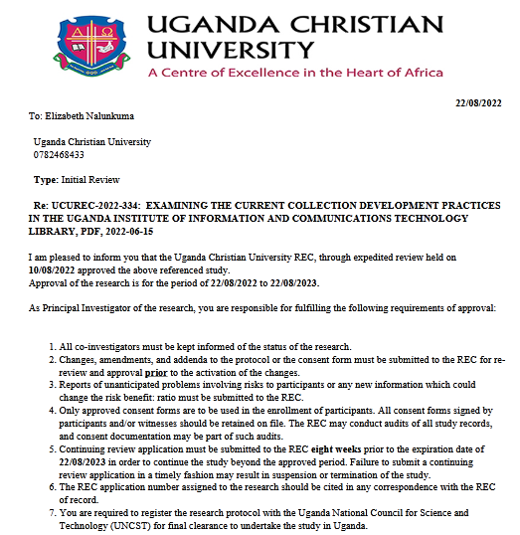

Appendix 2: Letter to study participants
Dear study participants,
I am Elizabeth Nalunkuma, a Master's student of Library and Information Science at Uganda Christian University, Mukono. I am currently undertaking research aimed at examining the current collection development practices at Uganda Institute of Information and Communication Technology (UICT).The objectives of this research are: to explore the current collection development practices at the UICT library, to assess the factors that influence the current collection development practices at the UICT library, to investigate the barriers to the current collection development practices at the UICT library, and to propose strategies for improving the current collection development practices at the UICT library. I humbly request you to participate in this study by providing relevant data related to the objectives of the study. This consent form provides information about the aim, objectives, significance, limitations and procedures to be used during the study. As a way of maintaining confidentiality, I will uphold all key information that can be used to identify you, your participation is voluntary. For any queries about this study, contact the researcher on Tel. no. 0782468433/ 0794900309, contact the Chairperson, Uganda Christian University Research Ethics Committee (UCU-REC), Prof. Waiswa on 0772405357; email: pwaiswa@musph.ac.ug or UCU- REC Secretariate, Mr. Osborn Ahimbisibwe on 0775737627; email: onhimbisibwe@ucu.ac.ug. If you would like to proceed to participate in this study, kindly read through the consent details below:

Consent to participate in the interviews
1. I hereby confirm that I have been informed by the researcher, Elizabeth Nalunkuma, about the nature and conduct of this study.
2. I have the opportunity to ask any questions related to this study.
3. I have received, read, and understood the participant letter of information about the study.
4. I understand that all the information the researcher gathers is confidential and will not prejudice me in any way.
5. I voluntarily agree to take part in this research.

Please tick the box below to indicate your consent.
- I have read the consent form and herby agree to participate in this study.
Participant's Signature………………….. Date…………………..

Appendix 3: Proposed Interview Schedules
Part I: Demographic Information for Librarians
1. What is your gender?
- Male
- Female
2. Under which age group do you lie?
- 30 years and below
- 30-40 years
- 40 years and above
3. What is your job title/rank?
- Assistant librarian
- Senior librarian
5. For how long have you worked at UICT?
- 1-5 years
- 6-10 years
- 11 years and above

Part II: Demographic Information for Faculty Staff
1. What is your gender?
- Male
- Female
2. Under which age group do you lie?
- 30 years and below
- 30-40 years
- 40 years and above
3. What is your job title/rank?
- Professor
- Associate professor
- Senior lecturer
- Lecturer
- Assistant lecturer
- Other (Please specify)
4. Which faculty/department are you currently teaching under?
- ICT
- Management
5. For how long have you worked at UICT?
- 1-5 years
- 6-10 years
- 11 years and above

Part III: Demographic Information for Student Representatives
1. What is your gender?
- Male
- Female
2. Under which age group do you lie?
- 30 years and below
- 30-40 years
- Over 40 years
3. What course are you studying at UICT?
- Please specify:................................................
4. For how long have you studied at UICT?
- 1 year
- 2 years

Part 4: Interview Questions for Faculty Staff
a) How collections are developed at UICT
- How are collections developed at UICT?
- Are you aware of the guidelines on procedures for collection development activities at UICT?
- Does your faculty have a library coordinator involved in collection development?
- Have you ever worked with a librarian to procure collections for UICT?
- Does UICT have a collection development policy and which resources does it cover (print or electronic, or both)?
- What does the collection development policy entail?
- How frequently are collections developed at UICT?
- How often are you involved in collection development at UICT and do you collaborate with faculty members?

b) Factors influencing the Current Collection Development Practices at UICT
- Which factors influence collection development at UICT?
- Are you aware of how much is allocated to collection development at UICT yearly?
- Who are the key stakeholders in the collection development process at UICT?
- What is the composition of collections in terms of print and electronic resources?
- What is your role as a faculty member in collection development?

c) Barriers to the Current Collection Development Practices at UICT
- What challenges has UICT faced during collection development?
- What challenges have you faced that are related to the existing collections and collection development process?

d) Measures to Improve Current Collection Development Practices at UICT
- Do you ever suggest ways of how to improve collection development at UICT?
- How often are the recommendations taken into consideration?
- What do you think management should do to improve collection development at UICT?

Part 5: Interview Questions For librarians
a) How collections are developed at UICT
- How are collections developed at UICT?
- Does UICT have a collection development policy and which resources does it cover (print or electronic, or both)?
- What does the collection development policy entail?
- How frequently are collections developed at UICT?
- How often are you involved in collection development at UICT and do you collaborate with faculty members?

b) Factors influencing the Current Collection Development Practices at UICT
- What factors influence collection development at UICT?
- Are you aware of how much is allocated to collection development at UICT yearly?
- Who are the key stakeholders in the collection development process at UICT?
- What is the composition of collections in terms of print and electronic resources?
- What is your role as a librarian in collection development at UICT?

c) Barriers to the Current Collection Development Practices at UICT
- What challenges has UICT faced during collection development?
- What challenges have you faced that are related to the existing collections and collection development process?

d) Measures to improve Current Collection Development Practices at UICT
- Do you ever suggest ways of how to improve collection development at UICT?
- How often are the recommendations taken into consideration?
- What do you think management should do to improve collection development at UICT?

Part 6: Interview Questions for Student Representatives
a) How collections are developed UICT
- Have you ever participated in developing collections at UICT?
- How often do you access collections at UICT?
- What are your preferred collections (print or electronic, or both)?
- Have you ever failed to obtain a collection you wanted?
- Have you ever participated with fellow students in the collection development process?

b) Factors influencing the current Collection Development Practices at UICT
- Do you think UICT has enough collections for the student population?
- Are your needs as a student considered in the current collection development practices?
- Do you think you can play a key role in collection development at UICT?
- If yes, how do you think you can play a key role in collection development at UICT?

c) Barriers to the current Collection Development Practices at UICT
- What challenges have you faced that are related to the existing collections and collection development process?

d) Measures to improve current Collection Development Practices at UICT
- Do you ever suggest ways of how to improve collection development at UICT?
- How often are the recommendations taken into consideration?
- What do you think management should do to improve collection development at UICT?

Appendix 4: Excerpts for Some of the Documents Reviewed
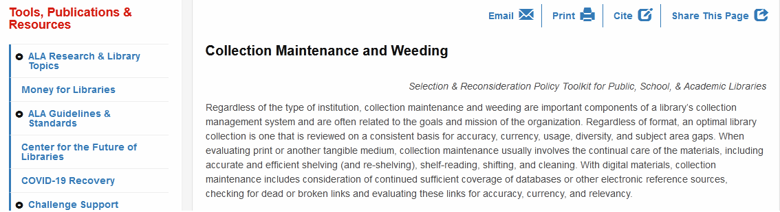

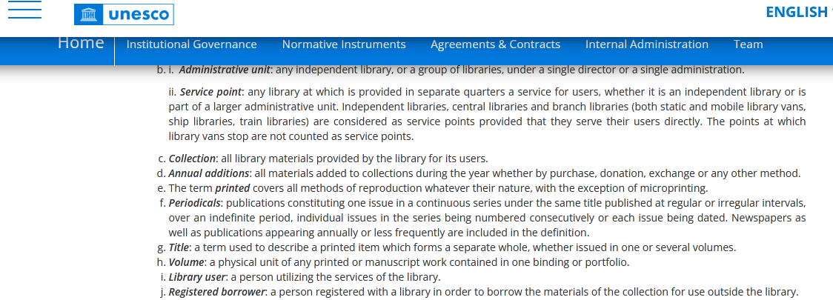

Appendix 5: Field photos of the researcher guiding the students on how to fill in the interview questions
